The ABCs  Always  Be  Caring  Avoid  Being  Cruel  Avoid  Being  Confrontational  Address  Behaviour  Concerns  Act  Because you  Care | Anti-Bullying Committee  An Anti-Bullying Committee is in place to help gather the views and opinions of different groups from the school community.  The Committee is:  - Class ambassadors and head pupils  - The Anti-Bullying Coordinator: Mr Collin  - A member of support staff: Mrs Hall  - A member of the governing body: Claire Bolton  The Committee will be meeting every half term to discuss anti-bullying issues and how we can make Thorpe Lea an even friendlier place to be.  If you have any thoughts on how we can make the school an even better place, please talk to someone on the committee and they can share your ideas with others.  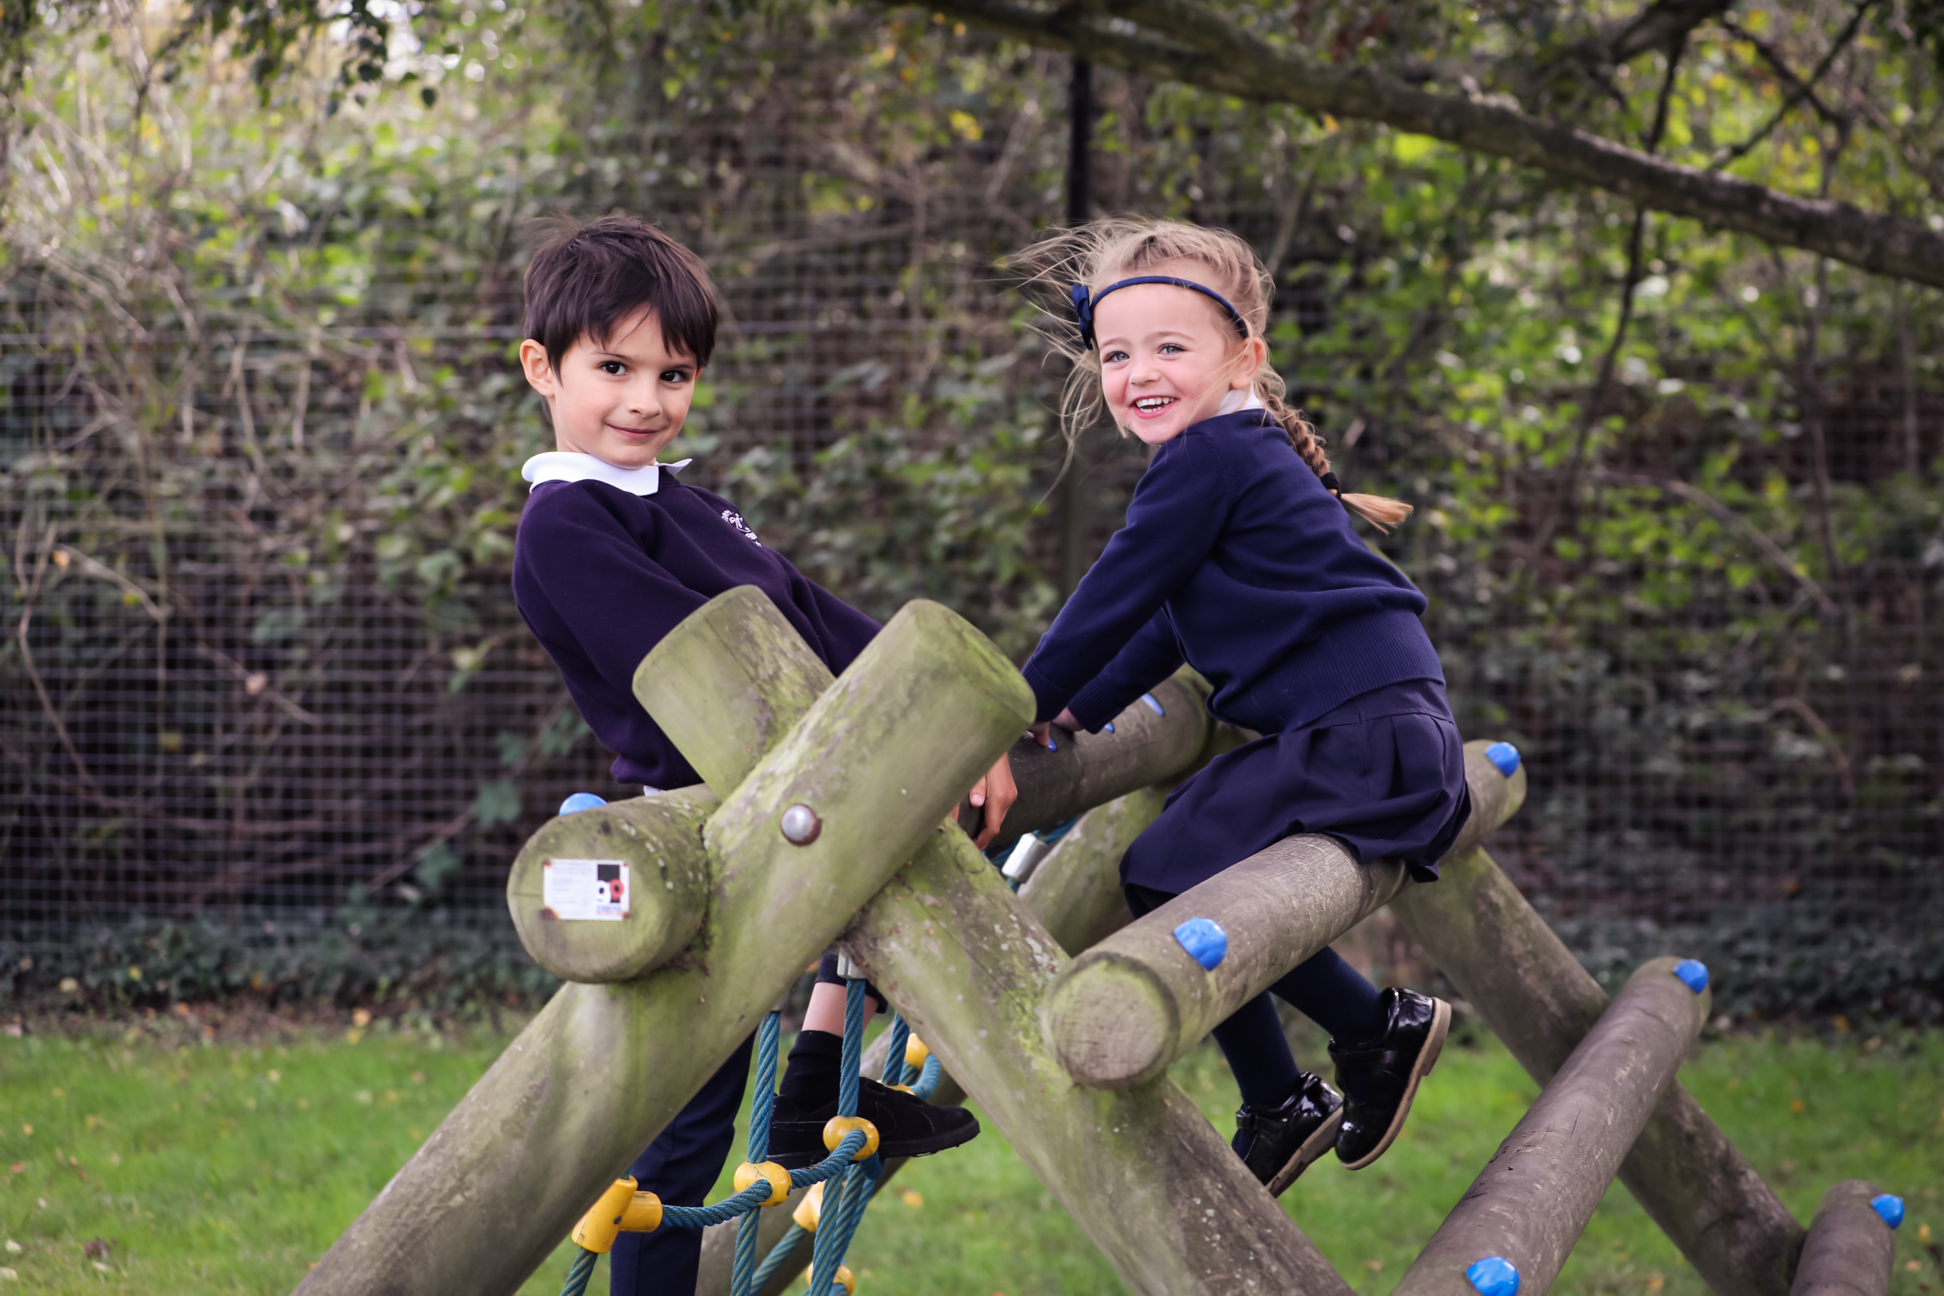 | Thorpe Lea Primary School  - Pupil  - Anti-Bullying Leaflet    

What is Bullying?  In our school, bullying is hurting someone more than once, on purpose, by using behavior or words which are meant to frighten or hurt that person. This could also include putting them in an uncomfortable position.  Bullying can be  Emotional – Hurting someone’s feelings, leaving them out, laughing at them on purpose  Physical – Punching, kicking etc.  Verbal – Name calling, teasing, gossiping  Written – Notes, letters, pictures  Cyber – Saying unkind things by text or via the internet, including social media.  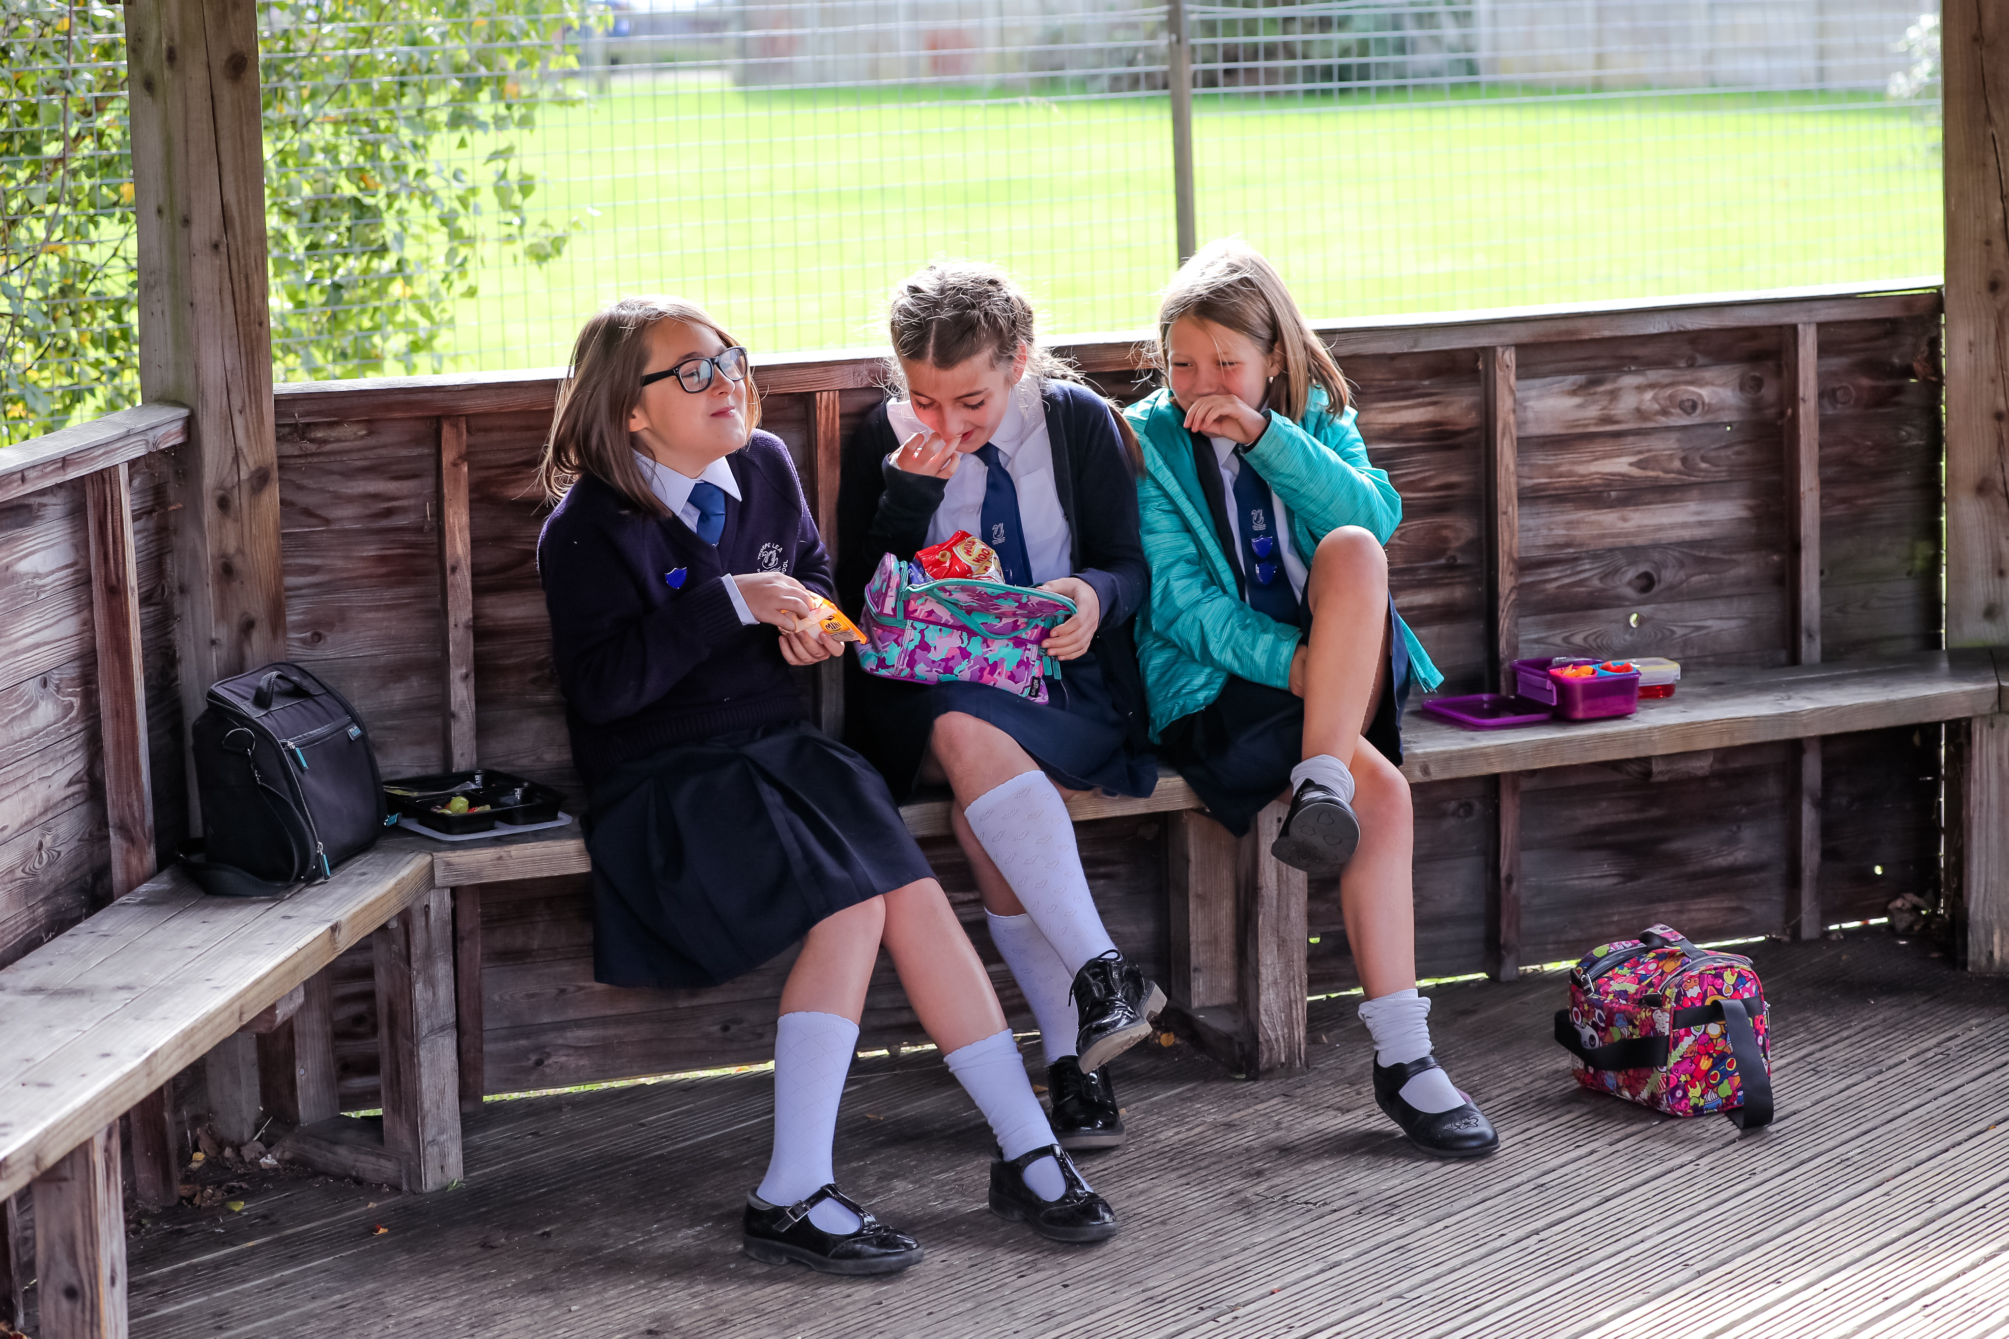 | Top Tips    DO:  - Ask them to stop and explain why you are upset  - Give them a chance to apologise  - Meet with them in the presence of an adult  - Give a message to Mrs Hall (ELSA)  - TELL SOMEONE!  DON’T  - Get angry  - Do what they say  - Hit them  - Say something unkind  - Think it’s your fault  - Hide it | I’m worried about someone else  - Don’t walk away and ignore it  - Ask the person to stop  - Don’t stay silent – tell someone  Who can I tell:  - A friend  - A class ambassador or head pupil  - Any adult at school  - A family member  We need to work together:  - To make our school a place where everyone can feel safe and happy  - To help everyone get along with each other because we believe that everyone has the right to be who they are  Adults at school will:  - Be ready to listen  - Help support the victim and the bully  - Work with families to help make things better

