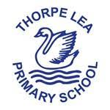

Reading at Thorpe Lea
Intent, Impact and Implementation Statement
Intent- What do we want our pupils to learn?
At Thorpe Lea, English is fundamental to the overall development of every child and their ability to access all aspects of the curriculum. As a result, we endeavour to ensure that children develop and foster a lifelong, healthy and enthusiastic attitude towards reading and writing.
Within our approach to reading, we understand the importance of spoken language in a pupils development across the whole curriculum but particularly in reading. We ensure the continual development of pupils’ confidence and competence in spoken language and listening skills. Pupils should develop a capacity to explain their understanding of books and other reading materials. Teachers build secure foundations using discussion to probe and remedy any misconceptions.
our intent at Thorpe Lea is to enable all children to be fluent readers who can talk eloquently about a wide range of texts and genres. We support children in developing their reading by exposing them to as many different reading genres as possible, while fostering excitement and love for reading. This begins in Nursery and continues up until they leave us in Year 6 and beyond.
Being a fluent reader with a love of books opens up many opportunities to the wider world, as well as enabling the children to access other areas of the curriculum more easily. Consequently, we ensure that reading is part of all areas of the curriculum so that it is seen as a life skill, which opens up the door to richer learning experiences and not just a discrete subject.
We want our children to not just be “secondary ready” but to be “life ready” as the reading skills which we teach them, they will use for the rest of their lives. It is therefore imperative that school and families work together to ensure our children receive the best opportunities possible.

Aims of Reading at Thorpe Lea:
- To enable children to see themselves as a reader and celebrate their success
- Children to read for pleasure, becoming enthusiastic and reflective readers
- Introduce children to language-rich texts, which link to the wider curriculum and respond to children’s interests
- Children to immerse themselves in a range of opportunities including reading aloud
- Help children to understand the relevance of reading to themselves and their lives
- Equip children with tools to be resilient, independent readers
- Ensure our children have sound phonic awareness and use a phonics first approach to reading
The most important thing that children will do at school is learn to read.

Implementation- How do we plan and teach reading?

The programmes of study for reading at Key Stages 1 and 2 consist of 2 dimensions:

- word reading
- comprehension (both listening and reading)

It is essential that teaching focus on developing pupils’ competence in both dimensions; different kinds of teaching are needed for each.

We dedicate time across the school daily to allow teachers to read aloud to their pupils. This fosters positive attitudes, enhances pupils’ motivation to read and develops vocabulary and other knowledge, including of books, authors and genres that they may not choose to read for themselves. The books read aloud might be either the same texts studied in English lessons or something outside of texts they are currently studying in order to give children exposure to a broad range of literature.

Skilled word reading involves both the speedy working out of the pronunciation of unfamiliar printed words (decoding) and the speedy recognition of familiar printed words. Underpinning both is the understanding that the letters on the page represent the sounds in spoken words. Please see our Phonics Intent which discusses our use of Read Write Inc to teach phonics.

Good comprehension draws from linguistic knowledge (in particular of vocabulary and grammar) and on knowledge of the world. Comprehension strategies develop through pupils’ experience of high-quality discussion with the teacher, as well as from reading and discussing a range of stories, poems and non-fiction. All pupils must be encouraged to read widely across both fiction and non-fiction to develop their knowledge of themselves and the world they live in, to establish an appreciation and love of reading, and to gain knowledge across the curriculum. Reading widely and often increases pupils’ vocabulary because they encounter words they would rarely hear or use in everyday speech. Reading also feeds pupils’ imagination and opens up a treasure house of wonder and joy for curious young minds.

It is essential that by the end of their primary education, all pupils are able to read fluently and with confidence.

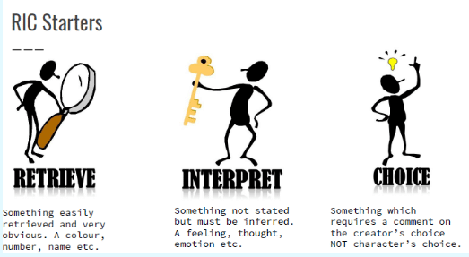

Comprehension starts with RIC

All our reading and comprehension sessions start with RIC. RIC stands for ‘Retrieve, Interpret and Choice’. Children will focus on rich texts and then explore a question focused on developing a specific reading skill. These strengthen children’s literal, inferential and analytical comprehension skills.

Reading Objectives

At Thorpe Lea, we recognise that reading lessons should not focus on limited objectives such as ‘we are learning to predict’ or ‘we are learning to infer’. Experienced readers draw on and use a variety of strategies all the time and not just one in isolation. After our starter, we remind children that we need to be a ‘strategic reader’:

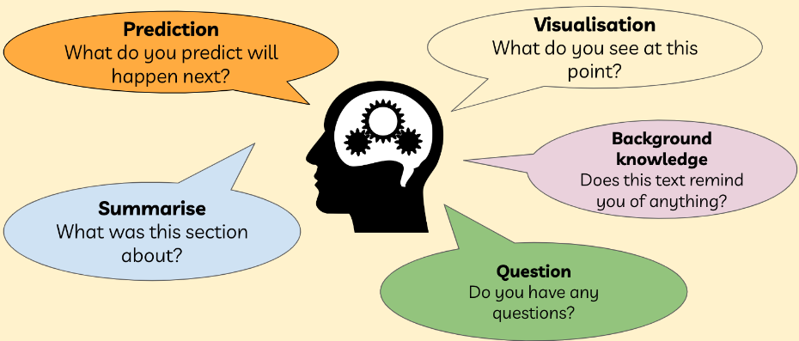
We make sure our lesson objectives are linked to reading comprehension strategies and not isolated reading skills.

Building our vocabulary

We then skim and scan the text together to identify words that we may be unfamiliar with. Children take part in a vocabulary activity whereby they match these words to their definitions and creating our own sentences using our newly learned vocabulary.

The Gradual Release Model
Children watch as the class teacher explicitly models comprehension by talking through the process aloud and physically modelling the act of completing questions and making the ‘invisible, visible’. The teacher will model against the success criteria and demonstrate how to locate the answer and to record it in. Children then write independently, with the class teacher assessing the room and providing instant feedback before drawing together a flexible focus group (if required). The teacher may continue this process throughout the lesson breaking up or ‘chunking’ the learning into manageable amounts to avoid cognitive overload.
Everyday assessment
Children will then mark their work at the end of the lesson. Teachers explain why answers are worth 1 or 2 marks and correct misconceptions there and then. This enables our children to get that instant feedback and to best prepare them for the standard assessment tests sat in Year 6.
Staff develop cross-curricular links with reading and other subjects to provide a relevant and meaningful curriculum for pupils. Reading contributes significantly to our teaching across the curriculum. Children are exposed to a range of texts linking to other subjects, including history and geography. Children are exposed to new vocabulary in all other subjects, including technical language.

Impact - What do we achieve by delivering reading in this way and how do we know?
The impact on our children is clear: progress, sustained learning and transferable strategies. With the implementation of the writing journey being well established and taught thoroughly in both key stages, children are becoming more confident readers and by the time they are in upper Key Stage 2, most genres and forms of literature are familiar to them.
As a result of high-quality teaching and immersion in high quality vocabulary, children achieve well and leave Thorpe Lea with an extensively improved lexicon, a passion for reading and high aspirations to continue to grow and develop throughout their education.

Monitoring and Review:
It is the responsibility of the English subject leader to:
- support colleagues in their teaching, by keeping informed about current developments in
reading and by providing a strategic lead and direction for this subject;
- develop, implement and review an action plan for reading and to review this throughout the academic year
- monitor reading throughout the school;
- enable staff to provide effective learning opportunities for all pupils

Assessment:
Assessment is used to monitor progress and to identify any child needing additional support as soon as they need it.
The primary reason for assessment at Thorpe Lea is to provide the pupil and the teacher with vital information which can then be used to improve future teaching and learning. Teachers will use a range of strategies to gain information about how well a child has understood an objective during the lesson including the use of effective questioning and collecting evidence from comprehension work as well as listening to the child read.

Appropriate oral and written feedback and peer or self-assessment tasks are then used to provide children with the information they need to continue to make rapid progress.
Different summative assessment tools are used to track pupils’ progress in reading carefully throughout the school to ensure that every child is making progress. These include:

- Assessment of comprehension in books and live in lessons
- Hearing children read aloud
- Monitoring of reading records

These assessments assist teachers in planning their next unit of comprehension and enable them to not only close gaps in children's learning but to continue to facilitate all children in taking their next step in developing their strategies as a reader.

