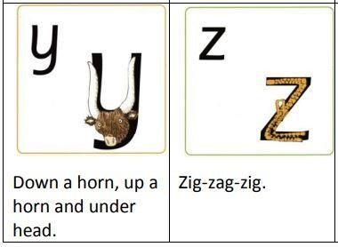


Read Write Inc.
Handwriting

Handwriting Teaching Guide

Through daily teaching and practice of handwriting we ensure that children develop sufficient handwriting skills.

We make the physical process of writing – handwriting – enjoyable from the start, so children see themselves as ‘writers’. We use mnemonics – memory pictures – to help children visualise the letter or join before they write it down. Children need to practise handwriting under the guidance of a teacher so they do not develop habits that will be difficult to undo later.

We do not ask children to copy letters or words. We need their attention to be focused on their own formation of letters and joins.

We allow 5 to 10 minutes for every handwriting session at the start of your Writing lesson.

Children learn the two basic joins: the arm join (diagonal) and the washing line join (horizontal) and the two variables for each join.

Handwriting position
Teach children that when you use the handwriting signal they automatically go into the perfect handwriting position:
- feet flat on the floor
- bottom at the back of the chair
- body one fist from the table
- shoulders down and relaxed
- back leaning forward slightly
- left/right hand holding the page • left/right hand ready in a tripod grip.

Handwriting Stage 1a Letter formation

- ‘Around’ letters: c a o d g q
- ‘Down’ letters: l t b p k h i j m n r u y
- ‘Curly’ letters: e f s
- ‘Zigzag’ letters: v w z x.

Handwriting Stage 1a: Letter formation

Children learn correct letter formation using the same picture mnemonics they have already learnt in the Speed Sounds Set 1 Lessons.

These letters are now taught in handwriting groups:
- ‘Around’ letters: c a o d g q
- ‘Down’ letters: l t b p k h i j m n r u y
- ‘Curly’ letters: e f s
- ‘Zig-zag’ letters: v w z x .

Children write on plain paper.
See the file named ‘Handwriting Stage 1a’ in the Handwriting files in Read Write Inc. Phonics Online.

The lesson plan
Practice the letters in the handwriting order (later on in this document). Use the following routine for every lesson (this is an example lesson for the letter g):

Demonstrate
- TOL ( Task-Orientated Learning) as you use your mental checklist to write the letter g.
  - start at her hair bobble on top of her head
  - round face
  - back to bobble ✓ very straight hair
  - round curl to finish.
Repeat a few times using MTYT.
- Ask the children to TTYP to say the mental checklist.
- Take feedback.
- Ask two partners to tell you how to write the letter g.
Repeat a couple more times until the children can say the mental checklist to each other.

Practice
- Check that the children are still sitting in the perfect handwriting position.
- Rub out the picture and any letters from the board – the children must not copy.
- Ask the children to write one letter, slowly and carefully. (Do not ask them to draw the handwriting picture.)
- Model again how you repeat writing the letter, getting a bit quicker each time.
- Go round the room praising what you see so others can hear. Don’t sit with one child. For example: “Nice round chin there! Love the long straight hair. What a great curl.”

Review
- Write the letter on the board and make one error, drawing on children’s common errors.
- Ask the children to TTYP to find your ‘two best bits’, for example, you remembered to start at the bobble. Then ask children to TTYP to find ‘one to fix’.
- Rewrite the letter perfectly, correcting using children’s feedback.
- Ask children to practise again.

On the next day, choose a new focus letter, and review one or two previously taught letters.

Note: Help children learn to visualise the letter as a picture and not the written checklist. Do not write the list on the board, though you may need a sticky note to help you remember to start with.

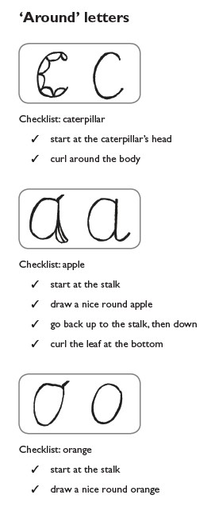
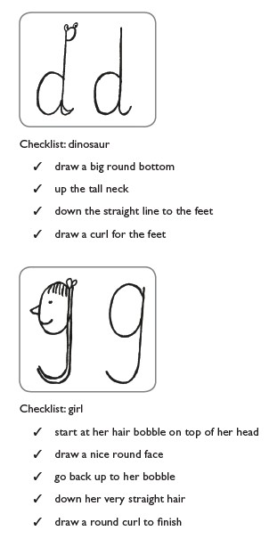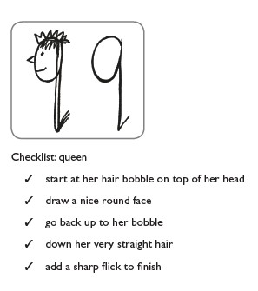

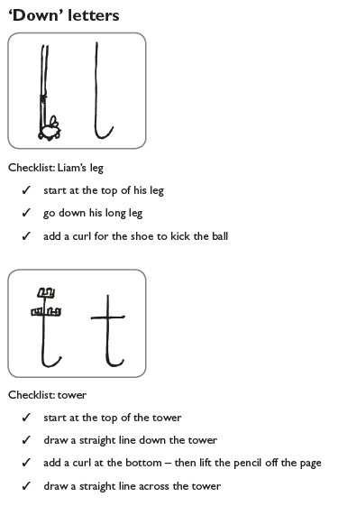
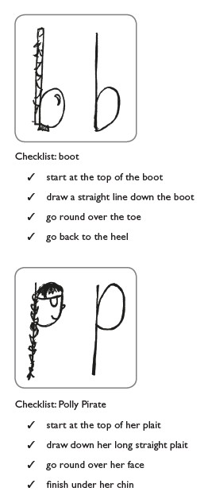
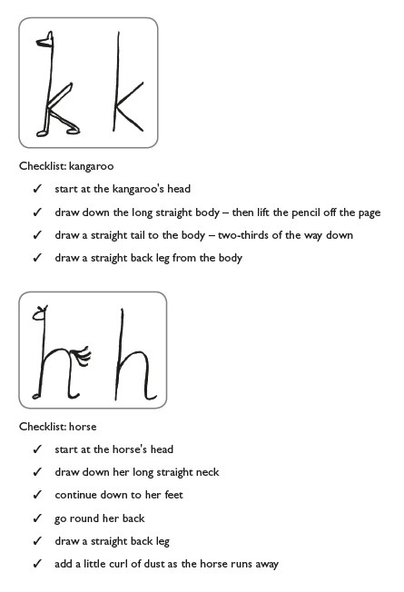

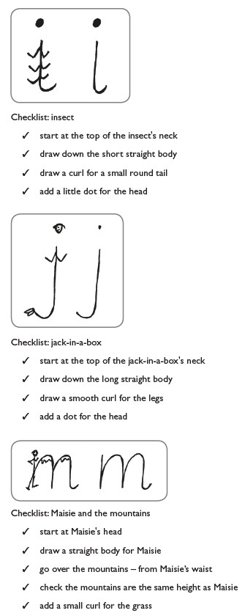
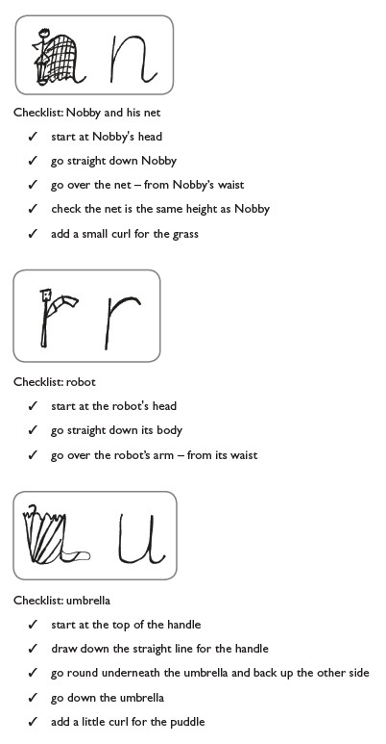

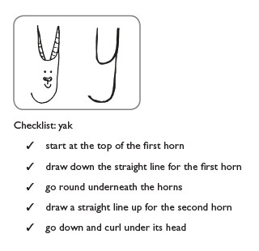

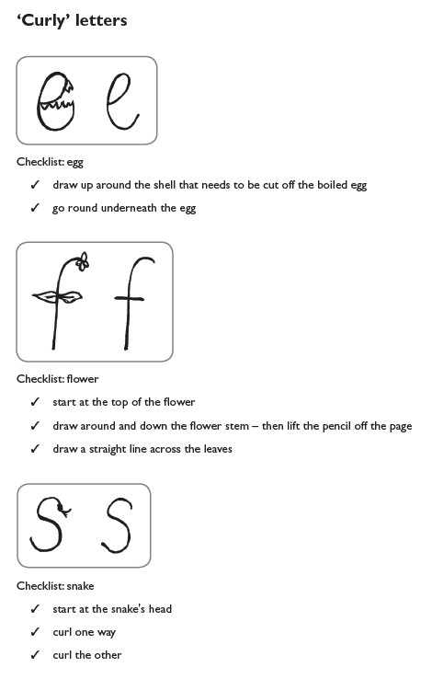

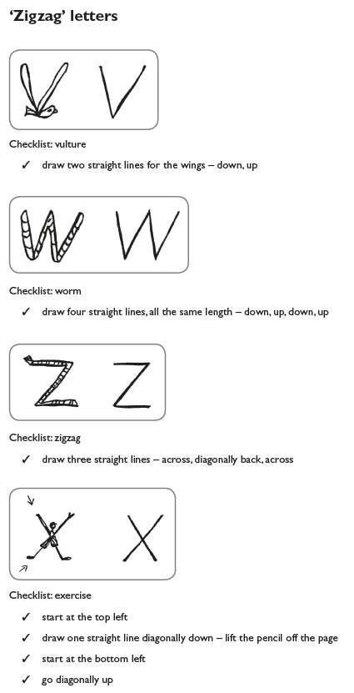
Down, around and up, down, around and up.

Handwriting Stage 1b
Relative size of letters

  - ‘Sun letters’: b d h k l (f and t are just a little bit smaller)
  - ‘Boat letters’: a c e i m n o r s u v w x z
  - ‘Water letters’: g j p q y.

Once children can form the letters correctly, they learn how to place the letters on the line. Picture mnemonics help children to visualise the size and placement.

  - Some small letters are called ‘boat letters’: a c e i m n o r s u v w x z .
  - Letters that are written below the line are called ‘water letters’: g j p q y .
  - Tall letters are called ‘sun letters’: b d h k l t f .
Children should write on wide-lined paper.

See ‘Handwriting Stage 1b’ in the Handwriting files in Read Write Inc. Phonics Online.

Explain that:
  - Some letters are the same size as the boat and are called ‘boat letters’: a c e i m n o r s u v w x z .
  - Some letters go below the water line and are called ‘water letters’: g j p q y .
  - Some letters are as tall as the sun and are called ‘sun letters’: b d h k l (f and t are just a little bit smaller).

The lesson plan
Use the following routine for every lesson. (This is a sample lesson for the word and.)
See ‘Handwriting Stage 1b’ in the Handwriting files in Read Write Inc. Phonics Online for the other words to practise.

Demonstrate
1. Draw the sun, boat and water pictures in the correct position on the line.
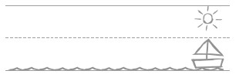

- Show children where to start a – level with the top of the boat. Recall the checklist for a as you write the letter.
- Show children where to start n – level with the top of the boat. Use the Checklist for n as you write the letter.
- Show children where to start d – level with the top of the boat. Use the Checklist for d as you write the letter.
- Ask children to TTYP: What size is each letter? (Choose from boat, water or sun.)
- Take feedback.

Practice
- Check that the children are still sitting in the perfect handwriting position.
- Rub out the word from the board – the children must not copy.
- Ask the children to write each letter, slowly and carefully.
- Model again how you repeat writing the word, getting a bit quicker each time.
- Go round the room praising what you see so others can hear. Don’t sit with one child. For example: “a is sitting on the line – good. You’ve made n into a boat letter.”

Review
- Write the word on the board and make one error, drawing on children’s common errors.
- Ask the children to TTYP to find your ‘two best bits’. Then ask them to TTYP to find ‘one to fix’.
- Rewrite the word perfectly, correcting using children’s feedback.
- Ask the children to practise again.
- Now ask them to find ‘two best bits’ and ‘one to fix’ in each other’s work.

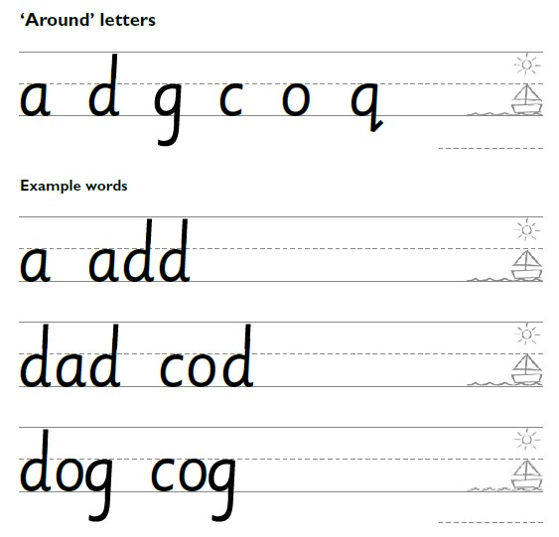

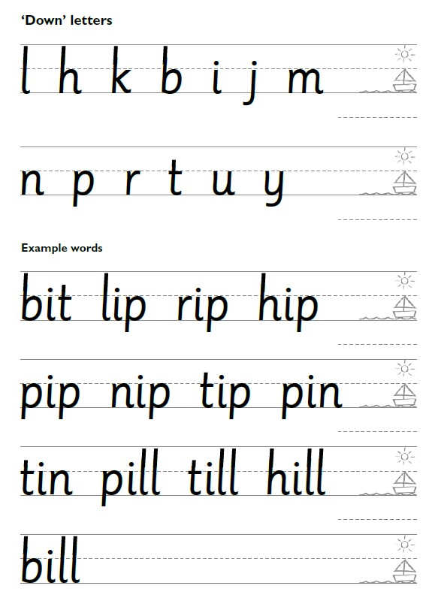

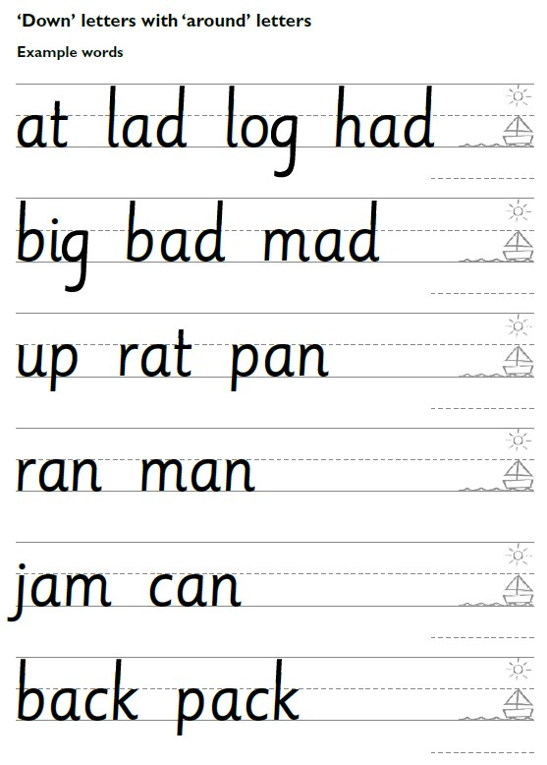
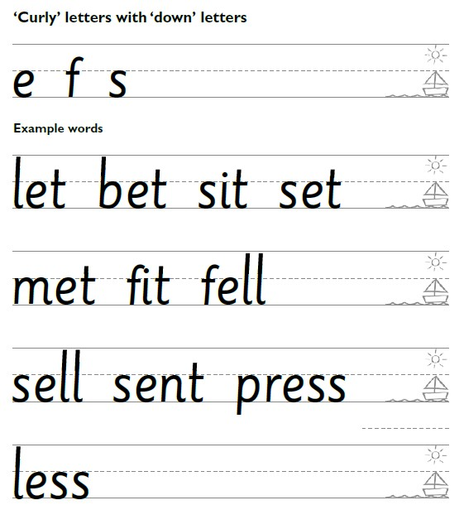

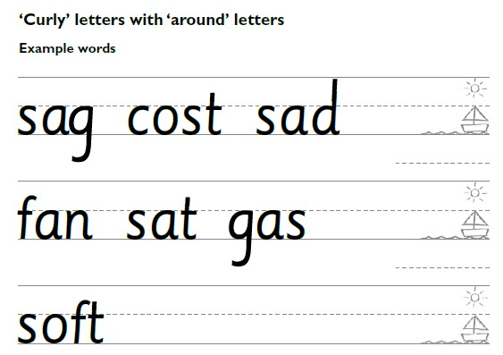

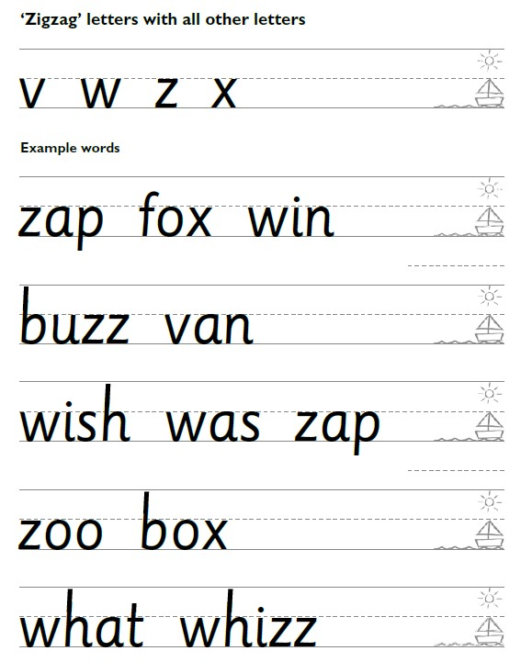

Handwriting Stage 2

Capital letters

Once children are secure with how to form all lower-case letters correctly. The next stage is to teach them how to form capital letters correctly. Use the sun, boat, water image to teach the children that the capital letters sit on the line and taller than the lower case letters. Use the capital letter formation guide to teach the children the different strokes needed to form each capital letter.

The Lesson Plan

Demonstrate
- Draw the sun, boat and water pictures in the correct position on the line.
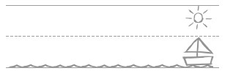

- Show the children where to start the letter and the strokes needed to form it.
Use the guide to ensure you are modelling this correctly.
- Remind children about the size of the capital letter.

Practice
- Check the children are sitting the perfect handwriting position.
- Rub out the model on the board, children must not copy.
- Ask the children to write each letter slowly and carefully.
- Model again how you write each letter, getting quicker each time.
- Circulate the room praising what you see.

Review
- Write the letter on the board, making an error.
- Ask the children to TTYP to find two positives and one fix.
- Rewrite the letter perfectly, correcting using the children’s feedback.
- Ask the children to practise again.
- Ask the children to work with a partner to find two positives and one thing to fix in their own work.
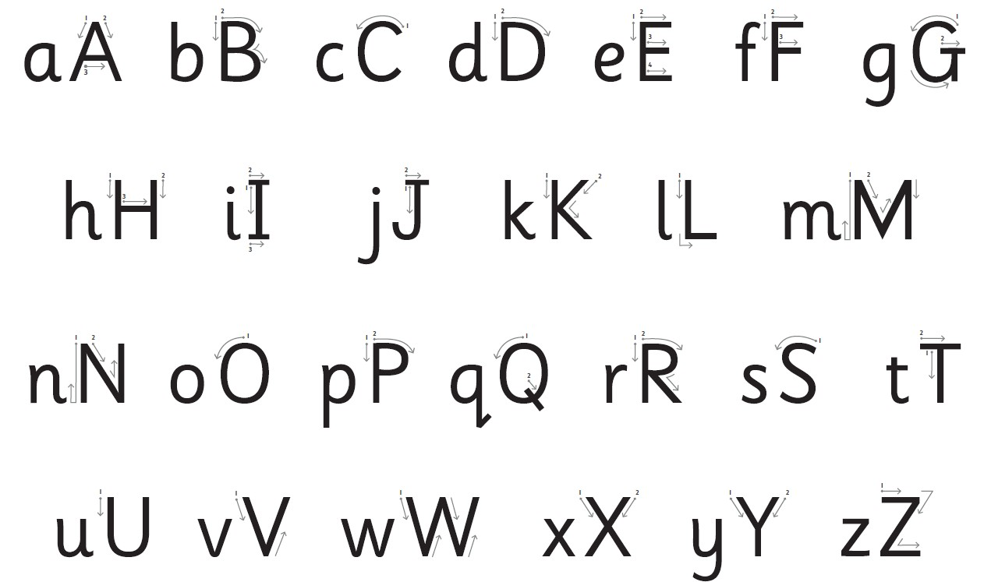

Handwriting

Stage 3

A mature style of handwriting for the following letters:
a d g o c q u y b p.

Explain to children that they are going to use new characters to help them develop a grown-up style of writing that will lead to joined-up writing. New pictures will help them to visualise the new shapes.

See ‘Handwriting Stage 2’ in the Handwriting files in Read Write Inc. Phonics Online.
Introduce the formation family: six sisters, two uncles and their two pets. The six sisters – Annie, Dina, Gabi, Olivia, Carina and Queenie – all look the same. Their mother tells them that they must all have a different haircut so people can tell them apart!
The uncles – Uncle Umberto and Uncle Yaseen – look just like the sisters, except they are bald on the top of their heads.
The family have a dog and a bunny whose faces are very similar too, but they have long ears.

The Lesson Plan

Practise the letters in the handwriting order. (See ‘Handwriting Stage 2’ in the
Handwriting files in Read Write Inc. Phonics Online.)

Use the following routine for every lesson. (This is an example lesson for the letter d.)

Demonstrate
- TOL as you use your mental checklist to write the letter d.
  - start at her hair bobble on top of her head
  - all the way over the top of her head
  - curve down her face
  - round chin
  - join the chin by her ear
  - up to the bobble
  - straight tall spiky hair – up and down
  - curve at the line and draw small flick (not curvy) Repeat a few times using MTYT.

- Ask the children to TTYP to say the mental checklist.
- Take feedback.
- Ask two partners to tell you how to write the letter d.

Repeat a couple more times until the children can say the mental checklist to each other.

Practice
- Use the handwriting signal to check that the children are still sitting in the perfect handwriting position.
- Rub out the picture and any letters from the board – the children must not copy.
- Ask the children to write one letter, slowly and carefully. (Do not ask them to draw the handwriting picture.)
- Model again how you repeat writing the letter, getting a bit quicker each time.
- Go round the room praising what you see so others can hear. Don’t sit with one child. For example: “Nice round chin there! Love the long straight hair. What a great curl.”

Review
- Write the letter on the board and make one error, drawing on children’s common errors.
- Ask the children to TTYP to find your ‘two best bits’, for example, you remembered to start at the bobble. Then ask children to TTYP to find ‘one to fix’.
- Rewrite the letter perfectly, correcting using children’s feedback.
- Ask children to practise again.
- Ask children to find ‘two best bits’ and ‘one to fix’ in each other’s work.

On the next day, choose a new focus letter, and review one or two previously taught letters.
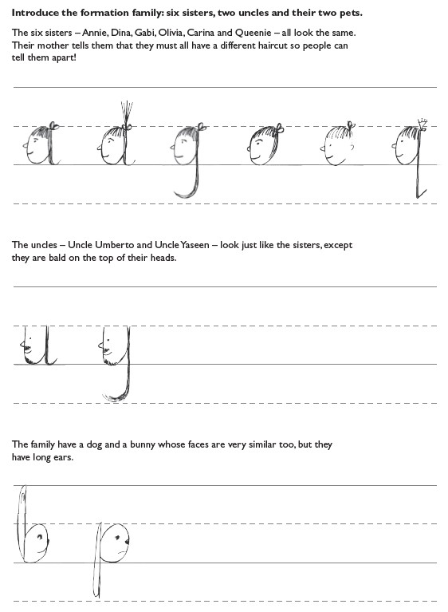

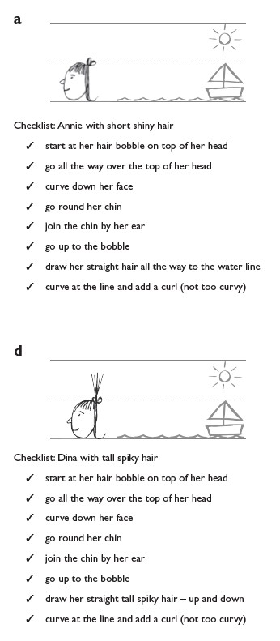
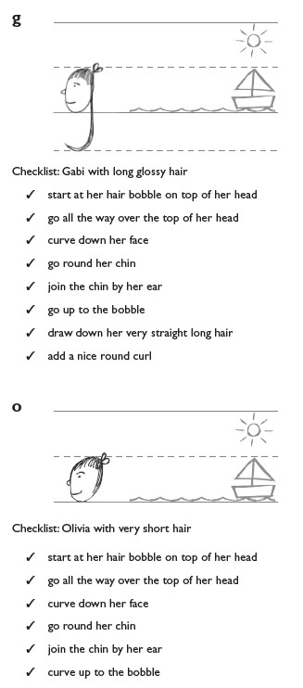
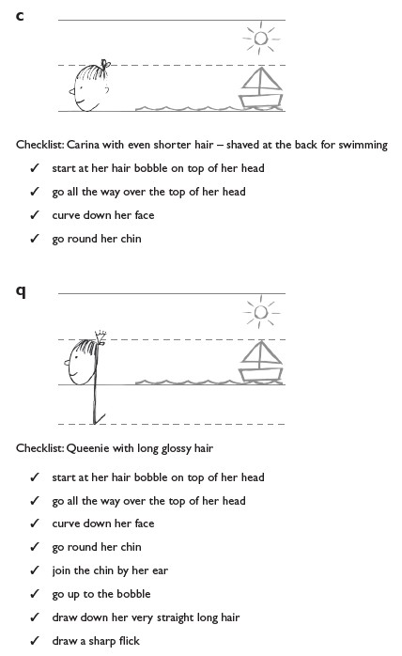

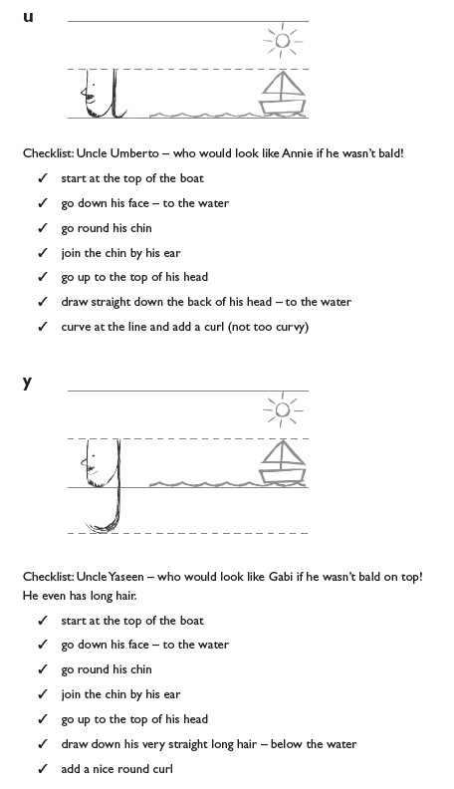
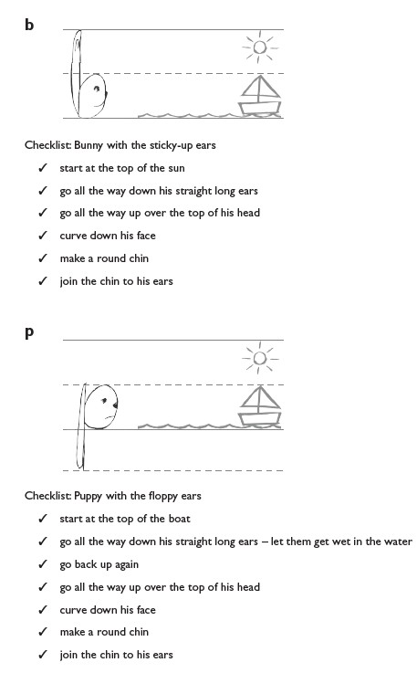

Handwriting

Stage 4
The arm join, and the washing line join

Explain to the children that there are two basic joins:
- The arm join (diagonal)
- The washing line join (horizontal)

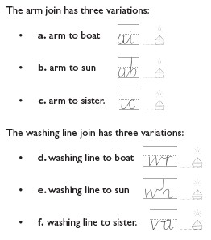
See ‘Handwriting Stage 3’ in the handwriting files in Read, Write, Inc. Phonics Online.

The Lesson Plan
Use the following routine for every lesson. (This is a sample lesson for joining a to i)
See ‘Handwriting Stage 3’ in the Handwriting files in Read Write Inc. Phonics Online for the joins to practise.

Demonstrate
1. Demonstrate how to write the letters.
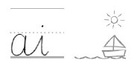
- TOL about where to start a – level with the top of the boat. Recall the checklist for Annie as you write the letter.
- TOL as you write the join – not too spiky, not too round, not too squeezed, not too spaced.
- TOL as you write i. Recall the checklist for i.
- Ask children to TTYP: What size is each letter? (Boat, sun or water.) What is good about your join?
- Take feedback.

Practice
- Use the handwriting signal to check that the children are still sitting in the perfect handwriting position.
- Rub out the joined letters from the board – the children must not copy.
- Ask the children to write each letter and the join, slowly and carefully.
- Model again how you repeat writing the letters and join, getting a bit quicker each time.
- Go round the room praising what you see so others can hear. Don’t sit with one child. For example: “I love the spacing of your join and the join is not too spiky or too round.”

Review
- Write the letters and join on the board and make one error, drawing on children’s common errors.
- Ask the children to TTYP to find your ‘two best bits’. Then ask them to TTYP to find ‘one to fix’.
- Rewrite the letters and join perfectly, correcting using children’s feedback.
- Ask the children to practise again.
- Now ask them to find ‘two best bits’ and ‘one to fix’ in each other’s work.

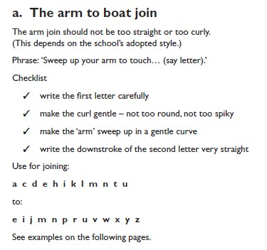

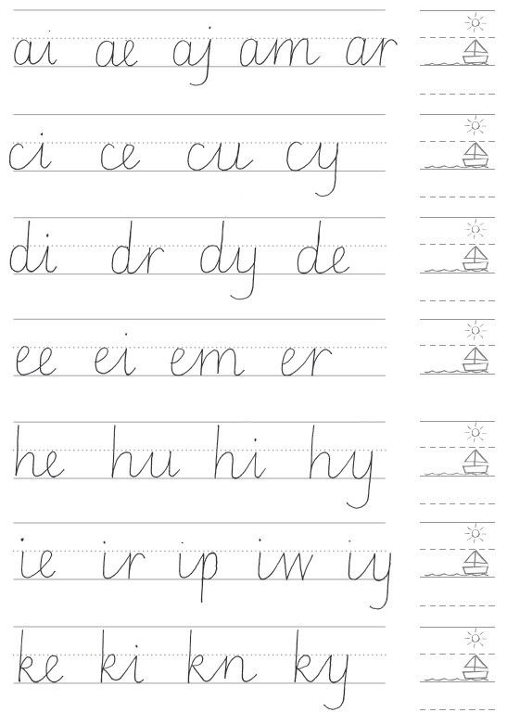
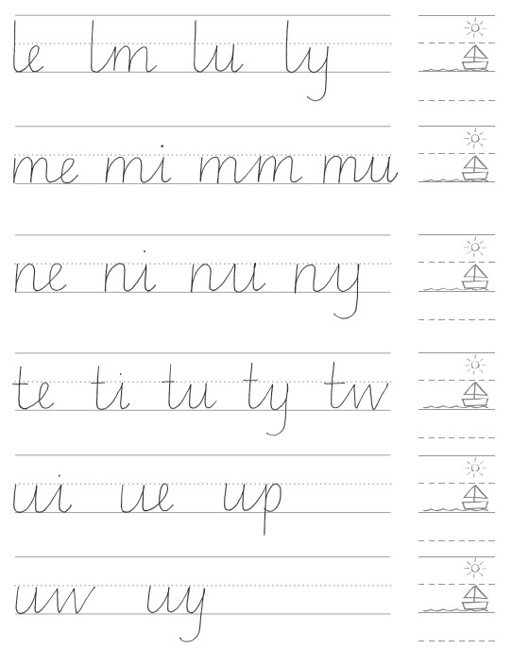

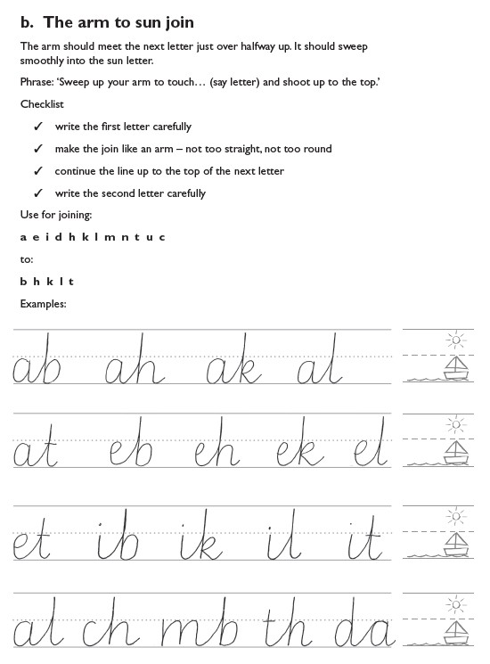

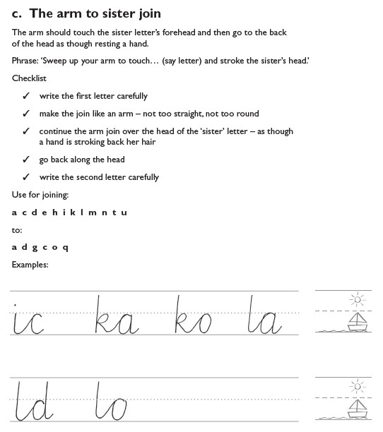

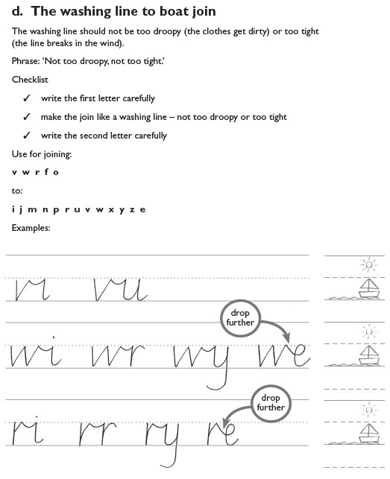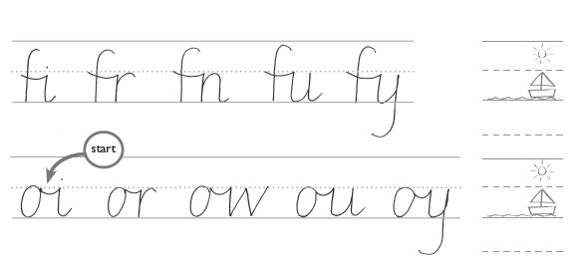
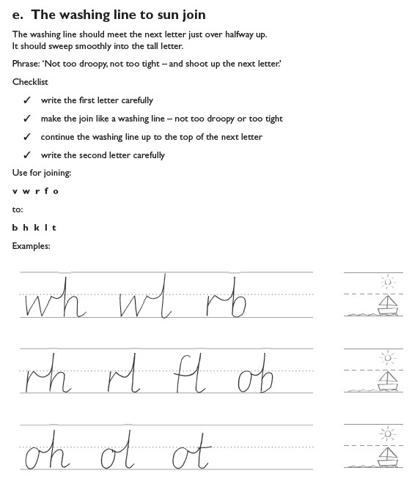

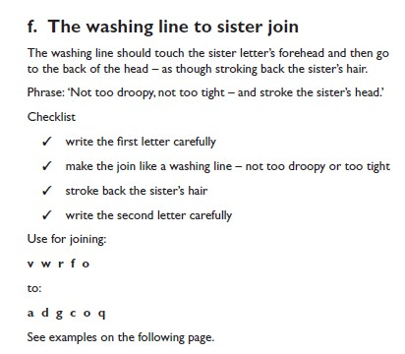

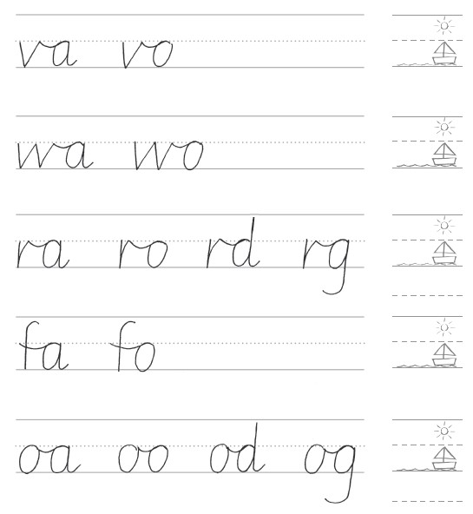

Thorpe Lea Handwriting Progression
Year Group | Autumn | Spring | Summer
Nursery  RWI Handwriting Guidance | Make marks on pictures to stand for their name | Write some or all of their name | Use some of their print and letter  Knowledge in early writing  Write their name  Write some letters accurately  Handwriting Phrases
Reception  RWI Handwriting Guidance | Write their name  Use RWI handwriting phrases to start to form letters correctly  Sit correctly at the table  Handwriting Phrases | Sit correctly at the table  RWI Handwriting Stage 1  Letter formation  ‘Around’ letters: c a o d g q  ‘Down’ letters: l t b p k h i j m n r u y  ‘Curly’ letters: e f s  ‘Zig-zag’ letters: v w z x  Handwriting Stage 1a | Sit correctly at the table  RWI Handwriting Stage 1  Form lower and upper case letters  correctly  Letter formation  ‘Around’ letters: c a o d g q  ‘Down’ letters: l t b p k h i j m n r u y  ‘Curly’ letters: e f s  ‘Zig-zag’ letters: v w z x  Handwriting Stage 1a
Year One  RWI Handwriting Guidance | Form lower and upper case letters correctly  Sit correctly at a table  RWI Stage 1  Relative size of letters  Once children can form the letters correctly, they learn how to place the letters on the line. Picture mnemonics help children to visualise the size and placement.  Some small letters are called ‘boat letters’: a c e i m n o r s u v w x z.  Letters written below the line are called ‘water letters’: g j p q y.  Tall letters are called ‘sun letters’: b d h k l t f. | Begin to use lead outs in some letters  Sit correctly at a table  RWI Stage 1  Relative size of letters  Once children can form the letters correctly, they learn how to place the letters on the line. Picture mnemonics help children to visualise the size and placement.  Some small letters are called ‘boat letters’: a c e i m n o r s u v w x z.  Letters that are written below the line are called ‘water letters’: g j p q y.  Tall letters are called ‘sun letters’: b d h k l t f. | Use lead outs for all letters  Form digits 0-9  Sit correctly at a table holding a pencil  comfortably and correctly  RWI Handwriting Stage 2  RWI Stage 2  Children learn a mature style of writing  that will  lead to joined-up writing.  Introduce the formation family: six sisters,  two uncles and their two pets.
Year Two  RWI Handwriting Guidance | Understand which letters belong to which handwriting families  RWI Stage 2  Handwriting Stage 2  Introduce the formation family: six sisters, two uncles and their two pets. | Understand which letters belong to which handwriting families  RWI Stage 3  Children learn the two basic joins: the arm join (diagonal) and the washing line join (horizontal) and the two variables for each join. | Understand which letters belong to which  handwriting families  RWI Stage 3  Children use the two basic joins: the arm  join (diagonal) and the washing line join  (horizontal)  and the two variables for each join.
Year Three & Four  Embedding RWI Stage 3 | Developing diagonal & horizontal joins  Arm join (arm to boat, arm to sun, arm to sister)  Washing line join (washing line to boat, washing line to sun, washing line to sister) | Developing diagonal & horizontal joins  Arm join (arm to boat, arm to sun, arm to sister)  Washing line join (washing line to boat, washing line to sun, washing line to sister) | Developing diagonal & horizontal joins  Arm join (arm to boat, arm to sun, arm to  sister)  Washing line join (washing line to boat’  washing line to sun, washing line to sister)
Year Three & Four  Embedding RWI Stage 3 | By the end of these sessions children should increase the legibility, consistency and quality of their handwriting by ensuring that  the down strokes of letters are parallel and equidistant and that lines of writing are spaced sufficiently so that the ascenders and descenders of letters do not touch.
Year Five & Six  Embedding RWI Stage 3 | Developing fluency, speed & style  Arm join (arm to boat, arm to sun, arm to sister)  Washing line join (washing line to boat, washing line to sun, washing line to sister) | Developing fluency, speed & style  Arm join (arm to boat, arm to sun, arm to sister)  Washing line join (washing line to boat, washing line to sun, washing line to sister) | Developing fluency, speed & style  Arm join (arm to boat, arm to sun, arm to  sister)  Washing line join (washing line to boat,  washing  line to sun, washing line to sister)
Year Five & Six  Embedding RWI Stage 3 | By the end of these lessons, most children should be able to write legibly, fluently and with increasing speed by choosing which  shape of a letter to use when given choices and deciding whether or not to join specific letters.

