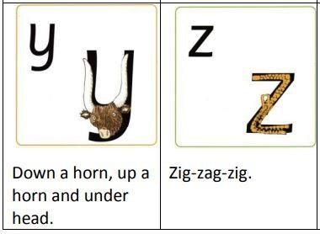
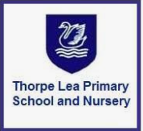

Read Write Inc.
Handwriting

Handwriting at Thorpe Lea

Why handwriting matters

Good handwriting increases children’s motivation: their belief in themselves as writers is predicated on this, particularly in their first years at school. Writing involves many processes, so having fluent handwriting is one less thing to think about.

As it says in the Writing Framework 2025:

“Pupils can gain great satisfaction and pleasure in learning how to write if the teaching is explicit, cumulative and engaging. As they see progress and sense growing competence, their motivation to improve increases. Gaining a new skill becomes a source of pride, in the same way as learning to play a musical instrument. It gives them freedom to express their ideas without being hampered by an uncomfortable pencil grip, poor letter formation or inaccurate spelling.”

Our teaching is grounded in one important principle: We always help children ‘visualise to memorise’. We use ‘picture hooks’ to help them build a picture of the letter or join before they write. We never ask children to copy letters, joins or words. Copying results in children writing what they think they see – often starting in the wrong place or writing an approximation of the letter or join. Our aim is to build children’s writing fluency.

Our approach

At Thorpe Lea, we teach children to read and write Set 1 sounds from the start of Reception as part of their Read Write Inc. Phonics lessons. Children first learn to form letters while they learn to read Set 1 letter-sounds in Reception.

As soon as they can read Set 1 sounds, we teach a separate daily 10-minute handwriting lesson. These handwriting lessons are at a different time from the Read Write Inc. lesson.

In Read Write Inc., we teach handwriting in four stages.

Read Write Inc. Handwriting – the four stages

Stage 1 begins as soon as most children can read Set 1 sounds. We continue to teach children to form letters correctly.
Stage 2 begins during Year 1. Children learn the relative size of letters and to form letters that will flow easily into a joined style.
Stage 3 follows straight on. Children learn how to join letters using two basic joins – the ‘bridge’ join, the ‘hill’ join and the two variations on each.
Stage 4 helps children develop a mature and speedy style.

Each stage ensures pupils meet the National Curriculum requirements for handwriting from Reception to Year 6.
Stage 1- Reception
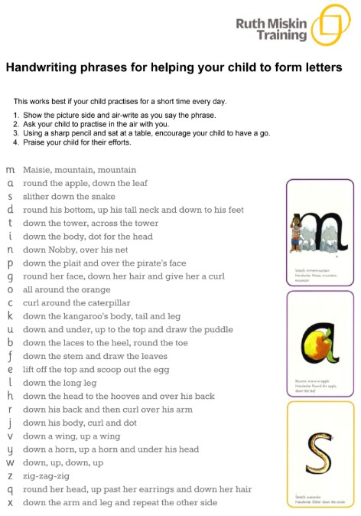

Stage 2


